1. Basic design principle :
(for making website more attractive and better looking we design our website by adding meaningful / attractive colors and adding style / typography . )

1. color theory : color play important for for designing website .
# color wheel
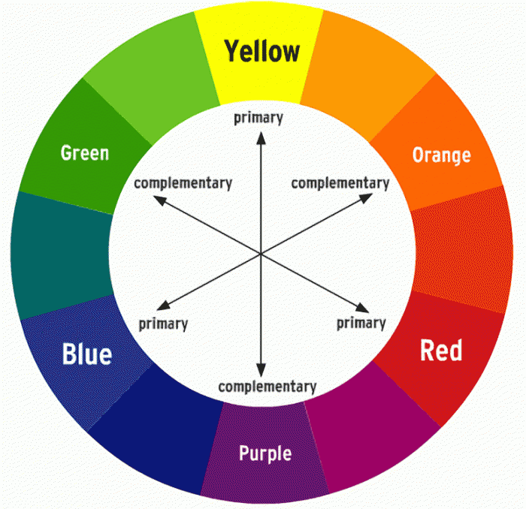
# meaning of colors :
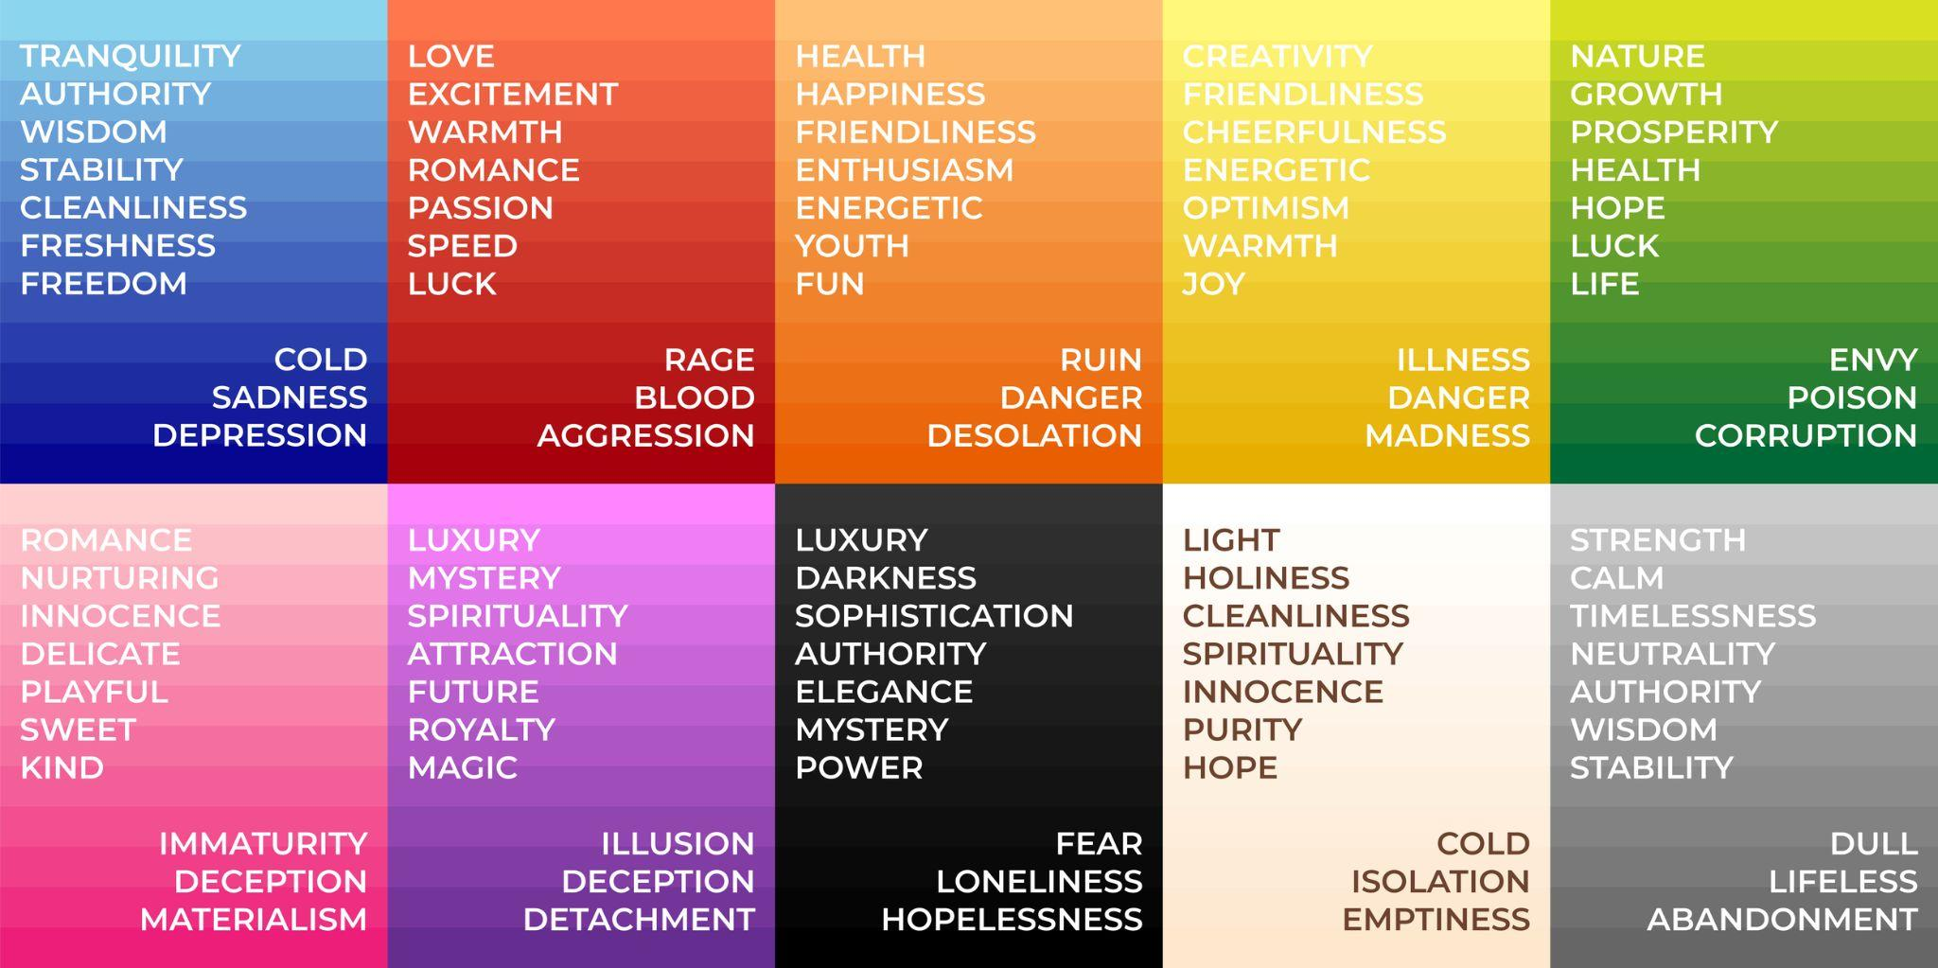
Eg 👍

netflix : use of red for excitement .


razorpay : use blue for stability & reliability.

# subtle color combination - monochromatic
// simlar type color
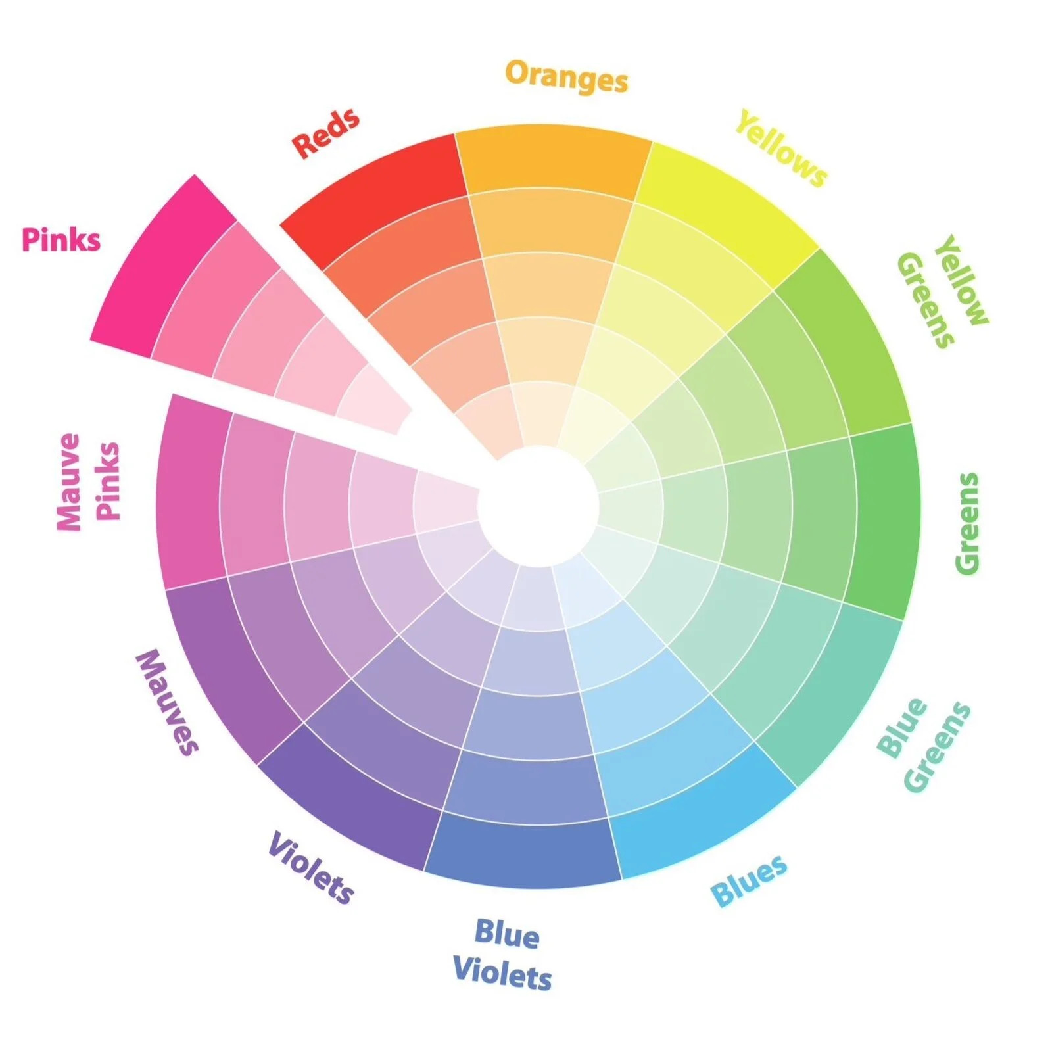

# impactful color - complementary
// totally two differnt color

# high contrast combination - triadic
// form triadic

For more detail search - color wheel canva
https://www.canva.com/colors/color-wheel/

2. typography :
style & appearance of text

# all the three txt indicate different meanings


# font falmilies: using diff font family for diff website make sense and stylish .
creating website :-
of icecreme : use fun type font
of museum : use old vintage type font
of portfolio : use professional type font
Etc.....

3. google fonts :
// library of fonts

website : https://fonts.google.com/

// adding google font
<!DOCTYPE html>
<html lang="en">

<head>
<meta charset="UTF-8">
<meta name="viewport" content="width=device-width, initial-scale=1.0">
<title>Document</title>
<link rel="preconnect" href="https://fonts.googleapis.com">
<link rel="preconnect" href="https://fonts.gstatic.com" crossorigin>
<link href="https://fonts.googleapis.com/css2?family=Manrope&display=swap" rel="stylesheet">

<style>
h1 {
font-family: "Manrope", sans-serif;
font-optical-sizing: auto;
font-weight: 900;
font-style: normal;

}
</style>
</head>

<body>
<h1>hello world</h1>
</body>

</html>

4. icons :

# icon form google icon
<!DOCTYPE html>
<html lang="en">
<head>
<meta charset="UTF-8">
<meta name="viewport" content="width=device-width, initial-scale=1.0">
<title>Document</title>
<!--copy code of Static icon font -->
<link rel="stylesheet" href="https://fonts.googleapis.com/css2?family=Material+Symbols+Outlined:opsz,wght,FILL,GRAD@24,400,0,0&icon_names=home" />

</head>
<body>
<!-- copy code of Inserting the icon -->
<span class="material-symbols-outlined">home</span>

</span>
</body>
</html>

# icon from font awsome :
<!DOCTYPE html>
<html lang="en">
<head>
<meta charset="UTF-8">
<meta name="viewport" content="width=device-width, initial-scale=1.0">
<title>Document</title>
<!-- copy link tag -->
<link rel="stylesheet" href="https://cdnjs.cloudflare.com/ajax/libs/font-awesome/7.3.0/css/all.min.css" integrity="sha512-ApSLB1Pd3/bZN8fWB/RG9YhN/7bd9Hkf3AGaE2mPfebjrxagjuBtx2GcgdqIlJkUzwylBo61r9Xa9NmgBI0swA==" crossorigin="anonymous" referrerpolicy="no-referrer" />
</head>
<body>
<i class="fa-regular fa-envelope"></i>

</body>
</html>

